Shortcut Tutorial

# To turn back on your Watch SASS and starting project

# Creating Variables

Make sure you are in **main.scss** file

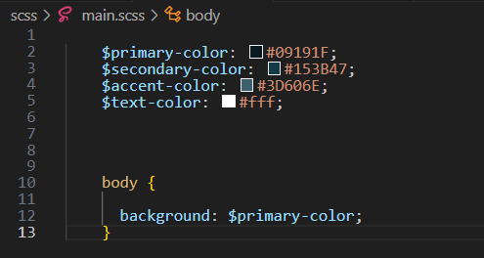

**$ variable name : hex color ;**

# Maps

In your **html file** make sure you have a div with the class of **main**

$font-weights:(

        "regular": 400,

        "medium": 500,

        "bold": 700

        );

    $font-colors: (

        "light": #f2e8d4,

        "middle": #9b8559,

        "dark": #1e1401

    );

With the map set up above now you can use it in the body rule in the scss file. the map.get pulls the stuff you created in the map, and throws it into the official CSS property

 body {

      background: $primary-color;

      font-weight: map-get($font-weights, bold);

      color: map-get($font-colors, middle);

    }

You can get the official CSS properties for your fonts [here](https://www.geeksforgeeks.org/css-cheat-sheet-a-basic-guide-to-css/#Font%20Properties), remember right goes into left with the syntax.

**font-family**: "arial";

**font-weight**: 10px;

**font-size**: 20px;

**color**: black;

**text-align**: right;

**font-style**: oblique;

**font-variant**: small-caps;

# Nesting

 .main {

        width: 75%;

        margin: 0 auto;

    #{&}__p {

        font-weight:map-get($font-weights, bold);

        &:hover {

            color:chocolate;

        }

    }

    }

# Separating Files Partial Files

Create a new file inside of your **scss folder**. Remember to add the **.scss** extension on it or it will not work. Remember to start a partial file with an **Underscore**.

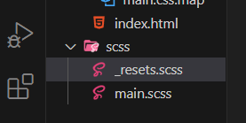

Write this for the _resets file

* {

    box-sizing: border-box;

    margin:0;

    padding:0;

}

Go back to the **Main.SCSS** file

This new file now needs to be imported into the main.scss

Notice that we **do not need** the **underscore** or the extension of **.scss** when we import it.

@import'./resets';

# Functions

# Creating your first SCSS function

Go to your **main.scss** file

We are going to be placing the functions right under our import statements on the page

@function weight($weight-name) {

    @return map-get($font-weights, $weight-name);

}

What we have now with out the code above used

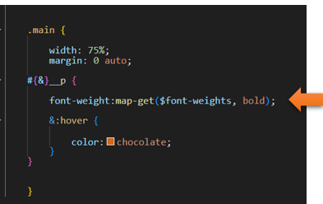

…and with our new function, we can change it to this: We also changed the code from bold to regular, but it is much simpler to write now.

Remember this is the function

@function weight($weight-name) {

    @return map-get($font-weights, $weight-name);

}

now after the official CSS code which we are putting it into, we only use the function name and put the size of the font weight in the parenthesis following it.

 .main {

        width: 75%;

        margin: 0 auto;

    #{&}__p {

        font-weight:weight(regular);

        &:hover {

            color:chocolate;

        }

    }

    }